


Sri Sri University
Predictive Maintenance for Aircraft Engines & Aviation Safety

SYNOPSIS
Predictive Maintenance

Baccalaureus Technologiae
Faculty Of Engineering & Technology

SUBMITTED BY
Subham Nayak | FET-BDS-2022-26-019
Indigibilli Harshit | FET-BDS-2022-26-015
Dhruti Deepam Mohapatra | FET-BDS-2022-26-005
Khushi Singhania | FET-BDS-2022-26-013
Lokesh Patra | FET-BDS-2022-26-20

Under the Guidance of
Dr. Pradipta Kumar Mishra
Asst. Professor
Faculty Of Engineering & Technology
Sri University

Content
Sl. No. | Topics | Page
1 | Introduction | 00
2 | Literature Survey | 01
3 | Methodology  [ Data Collection & Pre-Processing ] | 02
4 | [ Data Science & Machine Learning Algorithms ] | 03
5 | [ Failure Prediction & Anomaly Detection ] | 04
6 | [Maintenance Planning & Decision Making ] | 05-06
7 | Facilities Required for Proposed Work | 07-19
8 | Reference | 20

~ Introduction ~
Predictive Maintenance

Predictive maintenance (PdM) is a data-driven, proactive approach that aims to improve the reliability and safety of aircraft operations by forecasting potential failures and anomalies in aircraft components and engines. It can help airlines reduce maintenance costs, optimize resource allocation, and minimize downtime.
However, applying PdM in the aviation industry poses several challenges, such as the complexity and heterogeneity of the data, the high accuracy and reliability requirements, and the regulatory and ethical issues. In this project, we propose to develop a Data Science + Machine Learning based PdM system for aircraft engines that can leverage sensor and historical data to perform failure prediction and anomaly detection.
We will also evaluate the performance and impact of our system on maintenance planning and decision making.

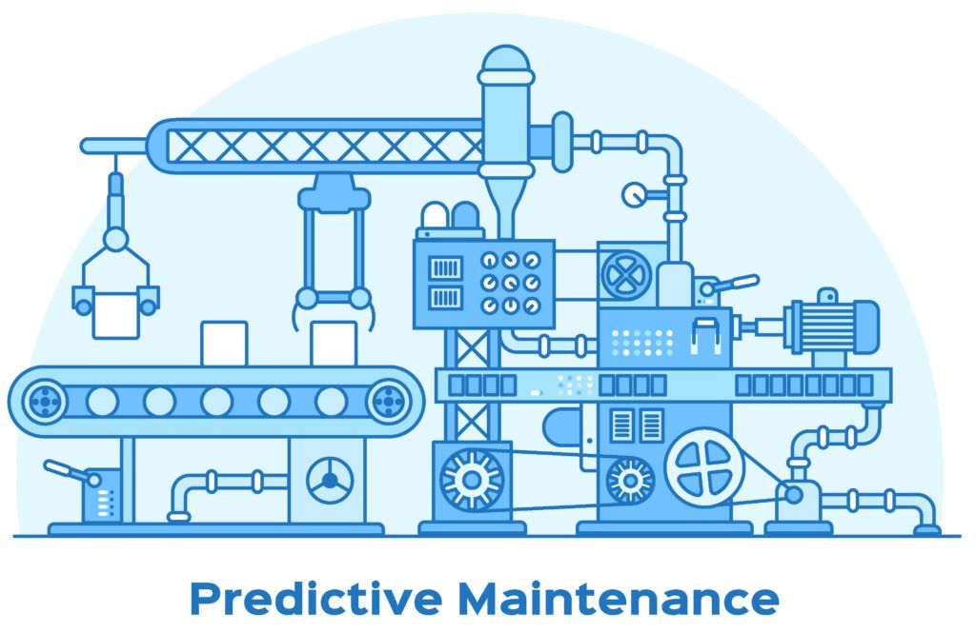

~ Literature Survey ~

Numerous projects have been made in the bright past of science which put light on the predictive maintenance of aeronautical safety. Our minor project has also been inspired by a few of them as listed below:

- Maria E., Jihad A., Mustafa H., Abdel M. (2022) | Towards Predictive Maintenance: The Case of The Aeronautical Industry | Procedia Computer Science [ Vol. 203, p.769 - 774 ] | Industrial Engineering Department AICSE Laboratory, ENSAM University Of Hassan II + Mathematics and Computer Sciences Department LTIM Laboratory, Faculty Of Sciences, University Of Hassan II, Casablanca 7955, Morocco
- Michael J. S., Wim J. C. V., Maria T. B., Pier M., Jongmyon K., Farzin P. (Sep. ‘22) | Predictive Maintenance for Defence Fixed-Wing Aircraft Sustainment and Operations | PubMed Central® | National Library of Medicine
- Izaak S., Kamran M., Ahsan I., Muhrad E. B. (2022) | Predictive Maintenance Analytics and Implementation for Aircraft: Challenges and Opportunities | Systems Engineering [ Vol. 2, Issue 2, p. 216 - 237 ]
- Juseong L., Mihaela M., Henk A. P. B., Pierre B., Floris F. (Feb. ‘23) | Analysing Emerging Challenges for Data-Driven Predictive Aircraft Maintenance Using Agent-Based Modelling and Hazard Identification | Aerospace Engineering [ Vol. 10, Issue 2, p.186 ] | Faculty of Aerospace Engineering, Delft University of Technology, Kluyverweg 1, 2629 HS Delft, The Netherlands + ONERA/DTIS, Université de Toulouse, BP 74025, CEDEX 04, 31055 Toulouse, France
- Sharan H. (2022) https://www.kaggle.com/code/sharanharsoor/aircraft-predictive-maintenance [ Python \ DataScience \ MachineLearning \ Aeronautics ] 5133 Views
- Maren D. D., Ian K. J., Steve K., Zakwan S. (Mar. ‘22) | A Rare Failure Detection Model for Aircraft Predictive Maintenance Using a Deep Hybrid Learning Approach | Neural Computing & Applications [ Vol. 35, p. 2991 - 3009 ] | 15K Accesses + 5 Citations
- Nhungoc (2019)
https://www.kaggle.com/code/ngocbe643/predict-maintenance-21-sensor
[ Python \ DataScience \ MachineLearning \ Aeronautics ] 7080 View
~ Methodology ~
Data Collection & Pre-Processing
The data sources for predictive maintenance for aircraft engines and aviation safety are mainly sensor and historical data from the aircraft engines. Sensor data include measurements such as temperature, pressure, vibration, and fuel consumption, which can indicate the health and performance of the engine components. Historical data include records of previous failures, maintenance actions, component removals, and shop findings, which can provide insights into the failure patterns and root causes.
To obtain and process the data, these steps were followed:
- Data Acquisition: We collected the sensor and historical data from various sources, such as the flight data recorder (FDR), the aircraft condition monitoring system (ACMS), the aircraft communications addressing and reporting system (ACARS), and the maintenance information system (MIS). We also ensured the data quality, security, and privacy, by applying encryption, authentication, and anonymization techniques.
- Data Preprocessing: We applied some preprocessing techniques to prepare the data for machine learning. These techniques include data cleaning, normalization, feature extraction, and feature selection. *Data cleaning involves removing or correcting any missing, noisy, or inconsistent data. *Normalization involves scaling the data to a common range, such as [0, 1] or [-1, 1]. *Feature extraction involves transforming the raw data into meaningful features, such as statistical or frequency-domain features. *Feature selection involves selecting the most relevant and informative features for your machine learning task, such as using correlation analysis, mutual information, or wrapper methods.
- Data Analysis: We analysed the data to understand its characteristics, distribution, and patterns. We used some data analysis techniques, such as descriptive statistics, visualization, and clustering, to explore your data and identify any trends, outliers, or anomalies.

Data Science & Machine Learning Algorithms

The data science and machine learning algorithms that are used for predictive maintenance for aircraft engines and aviation safety are as follows:

- Long Short-Term Memory (LSTM) Networks: These networks are a type of recurrent neural network (RNN) that can handle sequential data and capture long-term dependencies. They consist of memory cells that can store and update information over time, and gates that can regulate the flow of information in and out of the cells. They can learn from the temporal patterns and correlations in the sensor data and predict the future states and failures of the engine components.
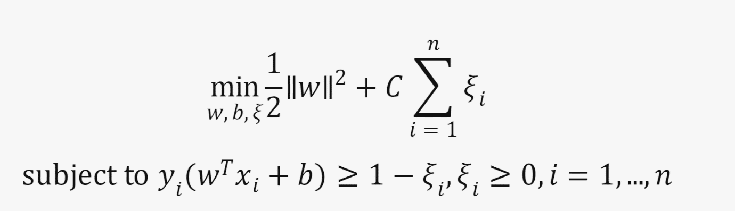
- Support Vector Machines (SVM): These are a type of supervised learning algorithm that can perform binary classification by finding the optimal hyperplane that separates the data into two classes. They can also perform multiclass classification by using one-vs-one or one-vs-all strategies. They can handle nonlinear data by using kernel functions, such as polynomial, radial basis function (RBF), or sigmoid, that map the data to a higher-dimensional space. They can be used to classify the engine components into healthy or faulty states based on the sensor data. The general formulation of an SVM is shown below:

where w is the weight vector, b is the bias term, ξ_{i}​ are the slack variables, C is the regularization parameter, xi​ are the input data, and y_{i}​ are the output labels.
- Random Forests (RF): It is a type of ensemble learning algorithm that can perform classification or regression by combining the predictions of multiple decision trees. Each decision tree is trained on a random subset of the data and a random subset of the features, which reduces the variance and the risk of overfitting. It can handle categorical and numerical data, and can also provide feature importance scores. It also can be used to classify the engine components into healthy or faulty states.
Failure Prediction & Anomaly Detection

To perform failure prediction and anomaly detection, I will use the following steps:
- Failure prediction: We used LSTM networks to predict the remaining useful life (RUL) of the engine components based on the sensor data. *The RUL is the number of cycles or hours that the component can operate before it fails. We trained the LSTM networks on historical data of engine components that have failed, and used them to forecast the RUL of new components. We also used a threshold value to determine when the component needs to be replaced or repaired. For example, if the RUL is less than 10 cycles, the component is considered to be in a critical state and needs immediate attention. We used some plots to show the predicted RUL and the actual RUL of the engine components, and compare them with the threshold value.
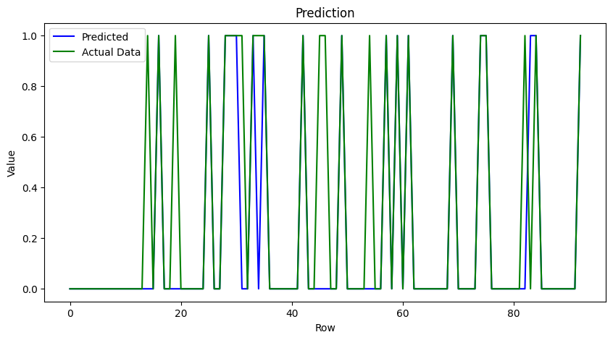

- Anomaly Detection: We can use K-Means Clustering to detect any deviations from the normal behaviour of the engine components based on the sensor data.
- Performance Evaluation: We used some metrics, such as accuracy, precision, recall, and F1-score, to evaluate the performance and reliability of our predictive maintenance system. These metrics measure how well the system can correctly classify or predict the engine components’ states and failures.
Maintenance Planning & Decision Making

To provide recommendations and insights for maintenance planning and decision making, we use the following steps:
- Maintenance Optimization: We use the failure prediction and anomaly detection results to optimize the maintenance schedules and resource allocation for the aircraft engines. We used a condition-based maintenance (CBM) strategy, which means that the maintenance actions are triggered by the actual condition of the engine components, rather than by a fixed time interval. We used the predicted RUL and anomaly scores to determine the optimal time and frequency of maintenance, and to prioritize the most critical or risky components. We also used the historical and sensor data to estimate the maintenance costs and resources, such as spare parts, tools, and personnel, and to allocate them efficiently. We used a table to show the optimized maintenance schedules and resource allocation, and compare them with the conventional maintenance strategy.

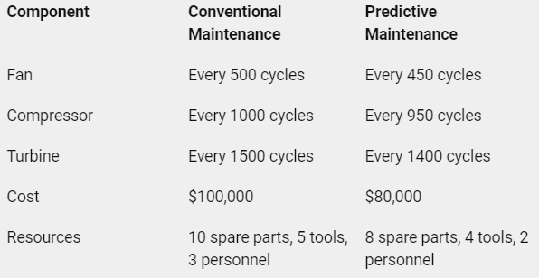

- Maintenance Impact: We used some methods, such as cost-benefit analysis, risk assessment, or sensitivity analysis, to assess the potential benefits and implications of the predictive maintenance system for the field of aircraft maintenance and aviation safety.
We used chart to show the impact of the system on different metrics, such as failure rate, availability, performance, and emissions.

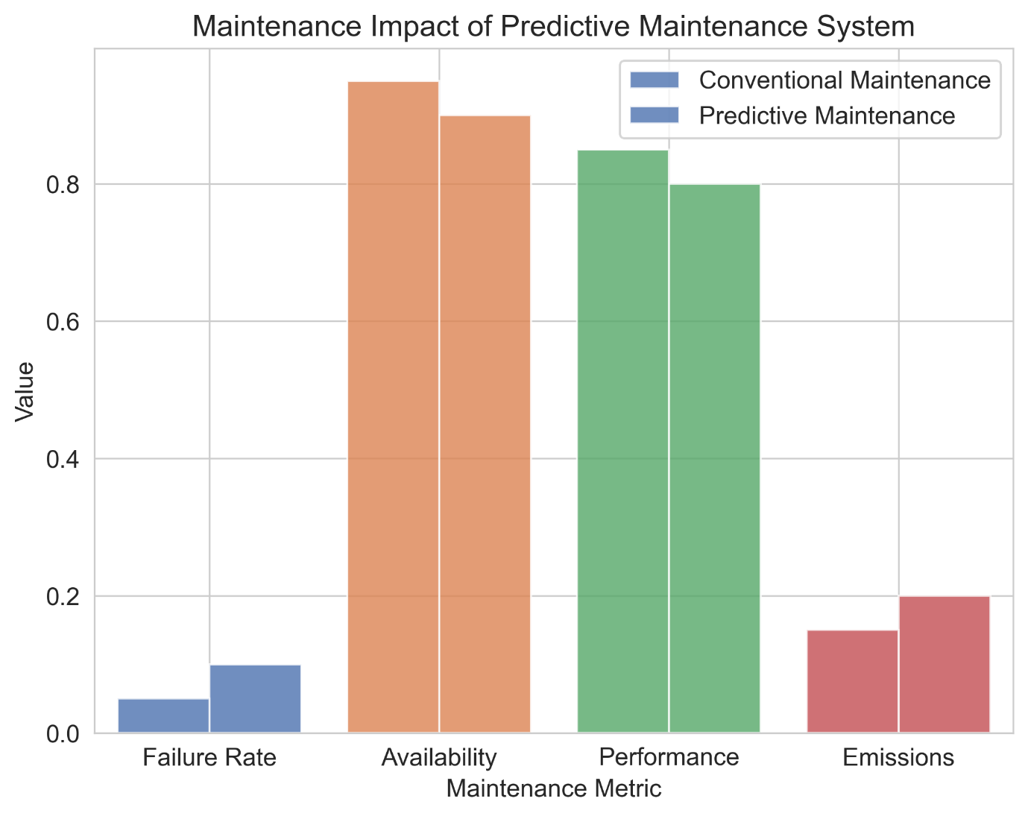

~ Facilities Required for Proposed Work ~

from tensorflow import keras
import pandas as pd
import numpy as np
import matplotlib.pyplot as plt
import seaborn as sns
import os
import seaborn as sns
from sklearn import preprocessing
from sklearn.metrics import confusion_matrix, recall_score, precision_score
from tensorflow.keras.models import Sequential,load_model
from tensorflow.keras.layers import Dense, Dropout, SimpleRNN, LSTM, GRU

#We will set the seed for reproducibility.
np.random.seed(1234)
PYTHONHASHSEED = 0

#Training data where the last cycle is the failure point for the engines.
train_df = pd.read_csv(r"C:\Users\Lokesh Patra\Documents\Projects\Minor Project\PM_train.txt", sep=" ", header=None)
#Test data where the failure point is not given for the engines
test_df = pd.read_csv(r"C:\Users\Lokesh Patra\Documents\Projects\Minor Project\PM_test.txt", sep=" ", header=None)
#We will print some rows of the train data
train_df.head(100)
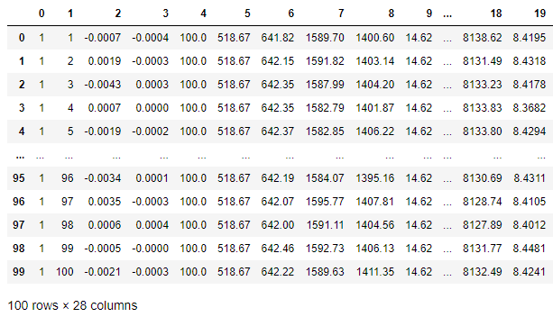

# Drop the NAN columns 26 and 27 using the dropna() method.
train_df.dropna(axis = 1, inplace = True)
test_df.dropna(axis = 1, inplace = True)

print(len(train_df))
print(len(test_df))
20631
13096

cols_names = ['id', 'cycle', 'setting1', 'setting2', 'setting3', 's1', 's2', 's3', 's4', 's5', 's6', 's7', 's8', 's9', 's10', 's11', 's12', 's13', 's14', 's15', 's16', 's17', 's18', 's19', 's20', 's21']
train_df.columns = cols_names
test_df.columns = cols_names

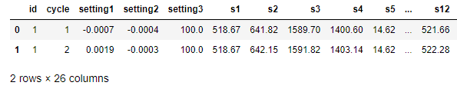
train_df.head(2)

#Load the ground truth for the test data, which indicates the remaining useful cycles for the engines
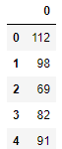
truth_df = pd.read_csv(r"C:\Users\Lokesh Patra\Documents\Projects\Minor Project\PM_truth.txt", sep=" ", header=None)
#We will drop the NAN column
truth_df.dropna(axis=1, inplace=True)
truth_df.head()

'''Data Preprocessing'''
1. Generating the classification target variable
2. Normalizing the data set

# method and specify which columns are to be considered while sorting using the parameter.
train_df.sort_values(['id','cycle'], inplace=True)
test_df.sort_values(['id','cycle'], inplace=True)

# Extract the maximum number of cycles for each engine id.
rul = pd.DataFrame(train_df.groupby('id')['cycle'].max()).reset_index()

# Name the columns and merge them with the training data.
rul.columns = ['id', 'max']
train_df = train_df.merge(rul, on=['id'], how='left')

# Now subtract the current cycle from the max (maximum number of cycles) to calculate the remaining useful life.
train_df['RUL'] = train_df['max'] - train_df['cycle']

#The RUL is calculated for each id.
train_df[['id','cycle','max','RUL']].head()
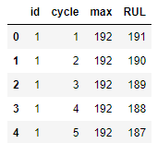

#We do not need "max" anymore.
train_df.drop('max', axis=1, inplace=True)

#We will make a label that indicates whether an engine is going to fail within w1 cycles.
w1 = 30
train_df['failure_within_w1'] = np.where(train_df['RUL'] <= w1, 1, 0 )

# Make a separate feature for the normalized value of the cycle column.
train_df['cycle_norm'] = train_df['cycle']
# Using the difference function, we exclude these columns from the normalization process.
cols_normalize = train_df.columns.difference(['id','cycle','RUL','failure_within_w1'])
# MinMax normalization (from 0 to 1) of sensor data
min_max_scaler = preprocessing.MinMaxScaler()
norm_train_df = pd.DataFrame(min_max_scaler.fit_transform(train_df[cols_normalize columns = cols_normalize, index = train_df.index)
#Join the normalized and non-normalized data.
join_df = train_df[['id','cycle','RUL','failure_within_w1']].join(norm_train_df)
train_df = join_df.reindex(columns = train_df.columns)

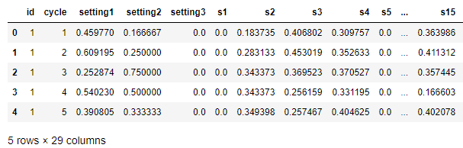
train_df.head()

#We will perform MinMax normalization (from 0 to 1)
test_df['cycle_norm'] = test_df['cycle']
#MinMax normalization (from 0 to 1) of the sensor data only
norm_test_df = pd.DataFrame(min_max_scaler.transform(test_df[cols_normalize]),
columns=cols_normalize,
index=test_df.index)
#Join the normalized and non-normalized data (it does not have 'RUL' and 'failure_within_w1')
test_join_df = test_df[test_df.columns.difference(cols_normalize)].join(norm_test_df)
test_df = test_join_df.reindex(columns = test_df.columns)
test_df = test_df.reset_index(drop=True)

# Let's calculate the total RUL by summing up the maximum cycles given in the test set and the
#Ground truth additional RUL
rul = pd.DataFrame(test_df.groupby('id')['cycle'].max()).reset_index()
rul.columns = ['id', 'max']
truth_df.columns = ['additional_rul']
#The respective id can be obtained by adding 1 to the index, as the index starts from 0.
truth_df['id'] = truth_df.index + 1
#Add the max cycles given in the test set and the additional RUL given in the ground truth DataFrame.
truth_df['max'] = rul['max'] + truth_df['additional_rul']
truth_df.drop('additional_rul', axis=1, inplace=True)
#Generate the RUL for the test data.
test_df = test_df.merge(truth_df, on=['id'], how='left')
test_df['RUL'] = test_df['max'] - test_df['cycle']
test_df.drop('max', axis=1, inplace=True)
#Generate the label columns w0 and w1 for the test data.
test_df['failure_within_w1'] = np.where(test_df['RUL'] <= w1, 1, 0 )
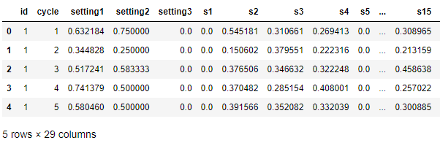
test_df.head()

‘’’ Exploratory Data Analysis ‘’’
sensor_cols = cols_names[5:]
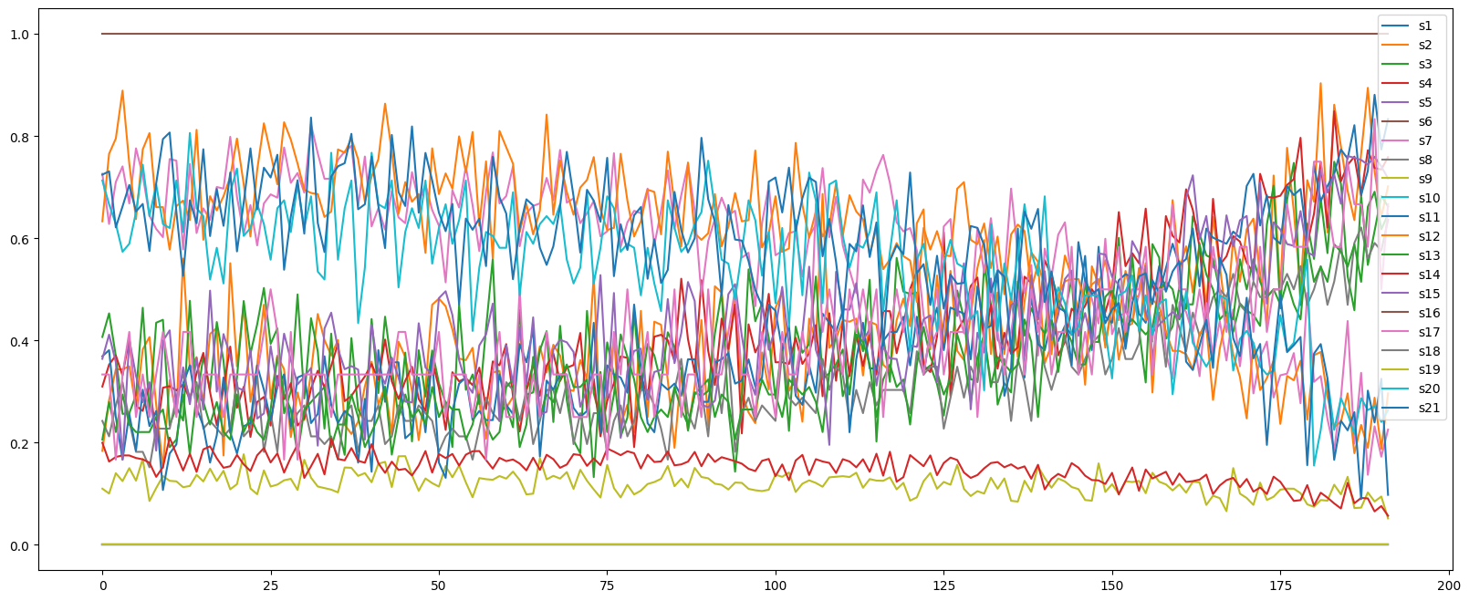
train_df[train_df.id==1][sensor_cols].plot(figsize=(20, 8))

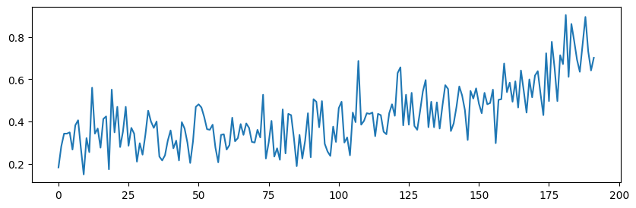
train_df[train_df.id==1][sensor_cols[1]].plot(figsize=(10, 3))

> Sensor 1 values increase when the cycle of number incrceases.
> Sensor 6 values decrease when the cycle of number increases.
> Most other sensors exhibit either an increasing or decreasing trend.

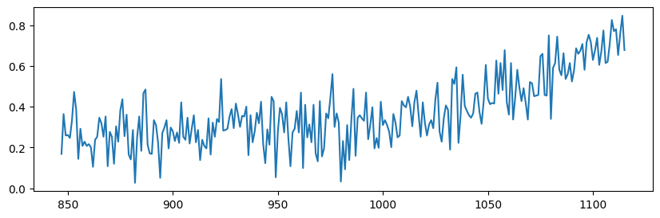
train_df[train_df.id==5][sensor_cols[1]].plot(figsize=(10, 3))

train_df[train_df.id==1][sensor_cols[6]].plot(figsize=(10, 3))
#We have plotted sensor1 observations for id 1 and id 5.
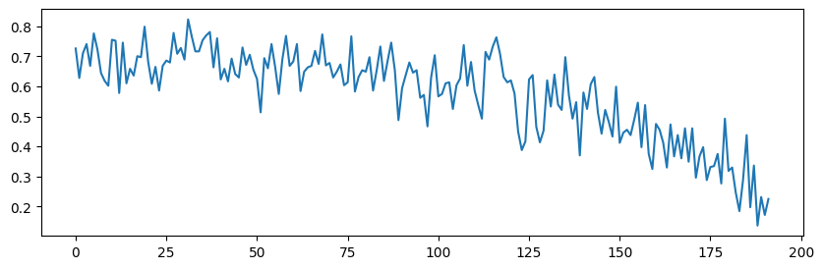
#Both observations have an upward trend with increasing cycles.

train_df[train_df.id==50][sensor_cols[6]].plot(figsize=(10, 3))
#We have plotted sensor6 observations for id 1 and id 50.
#Both observations have a downward trend with increasing cycles.
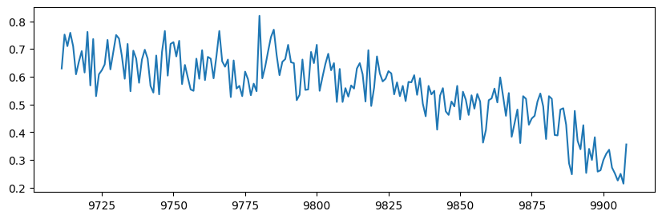
#We can sew that when the sensor values approach a particular value, the aircraft may fail to work soon.

'''Generating Input Sequence'''
# The sequence length to be used for predictions is as follows:
sequence_length = 50

# The function to generate sequences (samples, time steps, features) for a particular engine id is as follows:
def sequence_generator(feature_df, seq_length, seq_cols):
# We will not be using any sequence below seq_length.
# Convert the DataFrame into a NumPy 2D array.
feature_array = feature_df[seq_cols].values
num_elements = feature_array.shape[0]
# We want to generate sequences of 50 timesteps at a time.
# Hence, we will iterate over two sets of indices: (0,142),(50,192).
# For example, id1 has 192 rows, and its sequence_length is equal to 50.
# 0 50 -> From row 0 to row 50
# 1 51 -> From row 1 to row 51
# 2 52 -> From row 2 to row 52
# ...
# 141 191 -> From row 111 to 191
for start, stop in zip(range(0, num_elements-seq_length), range(seq_length, num_elements)):
yield feature_array[start:stop, :]
# Generate sequences for each engine id.
# unique() returns all the unique ids in a list.
seq_gen = (list(sequence_generator(train_df[train_df['id']==id], sequence_length, ["s2"])) # We take only one feature (s2).
for id in train_df['id'].unique())
# Concatenate the sequences of different engine ids into one array and convert that into a NumPy array
# [(142, 50, 25), ...] --> [(ntotal, 50, 25)].
#print(list(seq_gen))
seq_set = np.concatenate(list(seq_gen)).astype(np.float32)
# Let’s print the shape of the seq_set (number of samples, number of time steps, number of features)
seq_set.shape
(15631, 50, 1)

# The function to generate labels is as follows:
def label_generator(label_df, seq_length, label):
# Funtion will return
# This function will return the following:
# [[1]
# [4]
# [1]
# [5]
# [9]
# ...
# [200]]
# Convert the labels into a NumPy 2D array.

label_array = label_df[label].values
num_elements = label_array.shape[0]
# Remove the first label, as the first prediction will be the (seq_length+1)th label.
return label_array[seq_length:num_elements, :]
# Generate labels [[142,1], [121, 1], [3]] --> [1, 2, 3] (ntotal, 1).
label_gen = [label_generator(train_df[train_df['id']==id], sequence_length, ['failure_within_w1'])
for id in train_df['id'].unique()]
label_set = np.concatenate(label_gen).astype(np.float32)
label_set.shape
(15631, 1)
'''RNN Models'''
#A recurrent neural network (RNN) is a type of artificial neural network that processes sequential data inputs into sequential data outputs. RNNs are used in speech recognition and natural language processing. They are also used by Apple's Siri and Google's voice search.

**Simple RNN with 1 feature:
out_dim = label_set.shape[1] # 1 label/output for one sequence.
features_dim = seq_set.shape[2] # Number of features (1)

print("Features dimension: ", features_dim)
print("Output dimension: ", out_dim)

RNN_fwd = Sequential()

#Add the RNN unit.
#Understand the parameters.
RNN_fwd.add(SimpleRNN(
input_shape = (sequence_length, features_dim),
units = 1,
return_sequences=False))
RNN_fwd.add(Dropout(0.2))
RNN_fwd.add(Dense(units=out_dim, activation='sigmoid'))
#Compile the model.
RNN_fwd.compile(loss = 'binary_crossentropy', optimizer = 'adam', metrics = ['accuracy'])
print(RNN_fwd.summary())
#Define the path to save the model.
RNN_fwd_path = '/kaggle/working/RNN_fwd.h5'

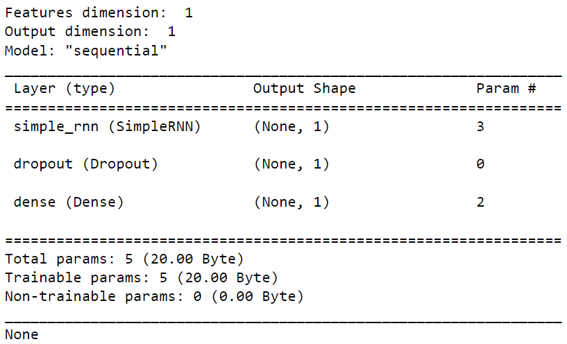

import time
epochs = 300
batch_size = 200
start = time.time()

# Fit the network.
RNN_fwd_history = RNN_fwd.fit(seq_set, label_set, epochs=epochs, batch_size=batch_size, validation_split=0.05, verbose=2,
callbacks = [keras.callbacks.EarlyStopping(monitor='val_loss', min_delta=0, patience=10, verbose=0, mode='min'),
keras.callbacks.ModelCheckpoint(RNN_fwd_path,monitor='val_loss', save_best_only=True, mode='min', verbose=0)]
)
end = time.time()
print("Total time taken for training: ", "{:.2f}".format((end-start)), " secs")
Epoch 3/300
75/75 - 0s - loss: 0.6760 - accuracy: 0.6617 - val_loss: 0.6562 - val_accuracy: 0.8018 - 326ms/epoch - 4ms/step
Epoch 4/300
75/75 - 0s - loss: 0.6409 - accuracy: 0.8017 - val_loss: 0.6253 - val_accuracy: 0.8018 - 328ms/epoch - 4ms/step
Epoch 5/300
75/75 - 0s - loss: 0.6136 - accuracy: 0.8017 - val_loss: 0.6002 - val_accuracy: 0.8018 - 325ms/epoch - 4ms/step
Epoch 6/300
75/75 - 0s - loss: 0.5893 - accuracy: 0.8017 - val_loss: 0.5748 - val_accuracy: 0.8018 - 332ms/epoch - 4ms/step
Epoch 7/300
75/75 - 0s - loss: 0.5635 - accuracy: 0.8017 - val_loss: 0.5494 - val_accuracy: 0.8018 - 326ms/epoch - 4ms/step
…
Epoch 132/300
75/75 - 0s - loss: 0.2459 - accuracy: 0.9000 - val_loss: 0.1765 - val_accuracy: 0.9246 - 314ms/epoch - 4ms/step
Total time taken for training: 44.88 secs

#The function for plotting the change in the model’s accuracy on the train and validation sets is as follows:
def plot_model_accuracy(model_name_history, width = 10, height = 10):

fig_acc = plt.figure(figsize=(width, height))
plt.plot(model_name_history.history['accuracy'])
plt.plot(model_name_history.history['val_accuracy'])
plt.title('model accuracy')
plt.ylabel('accuracy')
plt.xlabel('epoch')
plt.legend(['train', 'val'], loc='upper left')
plt.show()

#Call the function.
plot_model_accuracy(RNN_fwd_history,10,5)
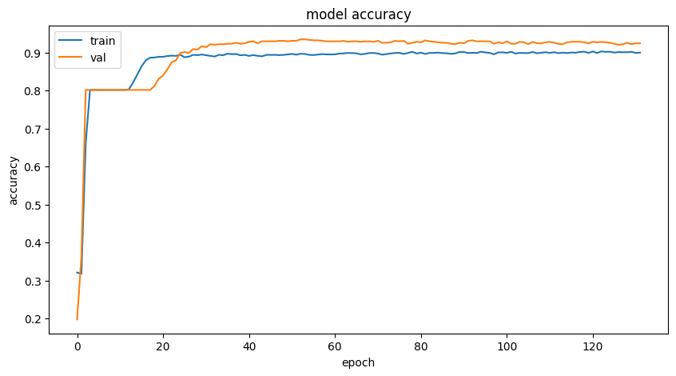

# We will define a function to plot the change in the loss on the train and validation sets.
def plot_training_curve(model_name_history, width = 10, height = 10):
fig_acc = plt.figure(figsize=(width, height))
plt.plot(model_name_history.history['loss'])
plt.plot(model_name_history.history['val_loss'])
plt.title('Model Loss')
plt.ylabel('Loss')
plt.xlabel('Epoch')
plt.legend(['Train', 'Value'], loc='upper left')
plt.show()

#Call the function.
plot_training_curve(RNN_fwd_history,10,5)
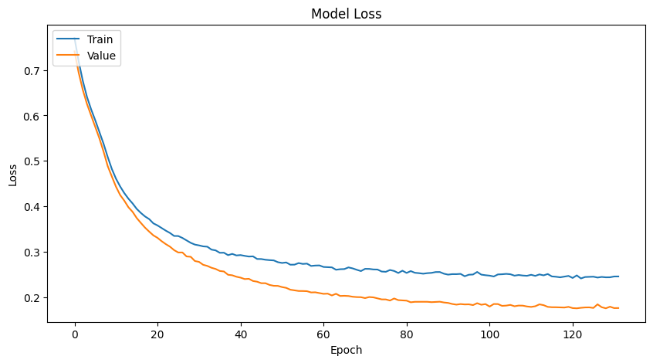

def analyze_model_on_train_set(input_sequence_set, model_name):

# The training metrics are as follows:
model_history_scores = model_name.evaluate(input_sequence_set, label_set, verbose=1, batch_size=50)
print('Train Accurracy: {}'.format(model_history_scores[1]))

#Make predictions and compute the confusion matrix.
y_pred = (model_name.predict(input_sequence_set, verbose=1, batch_size=200) > 0.5).astype("int32")
y_true = label_set

test_set = pd.DataFrame(y_pred)
test_set.to_csv('binary_submit_train.csv', index = None)

print('Confusion matrix\n- x-axis is true labels.\n- y-axis is predicted labels')
model_cm = confusion_matrix(y_true, y_pred)
print(model_cm)

# Compute the precision and recall.
model_precision = precision_score(y_true, y_pred)
model_recall = recall_score(y_true, y_pred)
print( 'Train Precision = ', model_precision, '\n', 'Train Recall = ', model_recall)

# Call the function.
analyze_model_on_train_set(seq_set, RNN_fwd)
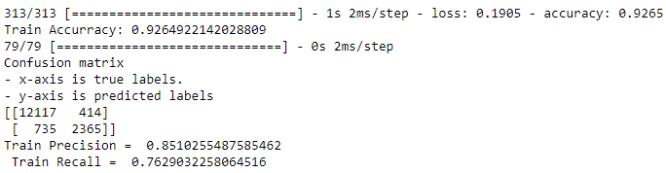

def analyze_model_on_test_set(input_sequence_columns, model_path, width= 10, height=5):
# We will consider all the last sequences of the test set.
last_test_seq = [test_df[test_df['id']==id][input_sequence_columns].values[-sequence_length:]
for id in test_df['id'].unique() if len(test_df[test_df['id']==id]) >= sequence_length]
last_test_seq = np.asarray(last_test_seq).astype(np.float32)

# Get the labels of the test set.
y_mask = [len(test_df[test_df['id']==id]) >= sequence_length for id in test_df['id'].unique()]
last_test_label = test_df.groupby('id')['failure_within_w1'].nth(-1)[y_mask].values
last_test_label = last_test_label.reshape(last_test_label.shape[0],1).astype(np.float32)

# If the best model weights were saved, load them.
if os.path.isfile(model_path):
print("using " + model_path)
model_estimator = load_model(model_path)

# Test the metrics.
start = time.time()
scores_test = model_estimator.evaluate(last_test_seq, last_test_label, verbose=2)
end = time.time()
print("Total time taken for inferencing: ", "{:.2f}".format((end-start)), " secs")

print('Test Accurracy: {}'.format(scores_test[1]))

# Make predictions and compute the confusion matrix.
y_model_estimator_pred_test = (model_estimator.predict(last_test_seq) >0.5).astype("int32")
y_true_test = last_test_label

test_set = pd.DataFrame(y_model_estimator_pred_test)
test_set.to_csv('binary_submit_test.csv', index = None)

print('Confusion matrix\n- x-axis is true labels.\n- y-axis is predicted labels')
model_estimator_conf_m = confusion_matrix(y_true_test, y_model_estimator_pred_test)
print(model_estimator_conf_m)

#Compute the precision and recall values.
model_estimator_precision_test = precision_score(y_true_test, y_model_estimator_pred_test)
model_estimator_recall_test = recall_score(y_true_test, y_model_estimator_pred_test)
f1_test = 2 * (model_estimator_precision_test * model_estimator_recall_test) / (model_estimator_precision_test + model_estimator_recall_test)
print( 'Test Precision: ', model_estimator_precision_test, '\n', 'Test Recall: ', model_estimator_recall_test,'\n', 'Test F1-score:', f1_test )

#Plot the predicted data in blue and the
#actual data in green to visually verify the accuracy of the model.
fig_verify = plt.figure(figsize=(10, 5))
plt.plot(y_model_estimator_pred_test, color="blue")
plt.plot(y_true_test, color="green")
plt.title('Prediction')
plt.ylabel('Value')
plt.xlabel('Row')
plt.legend(['Predicted', 'Actual Data'], loc='upper left')
plt.show()

#Call the function
analyze_model_on_test_set(["s2"], RNN_fwd_path, 10, 5)
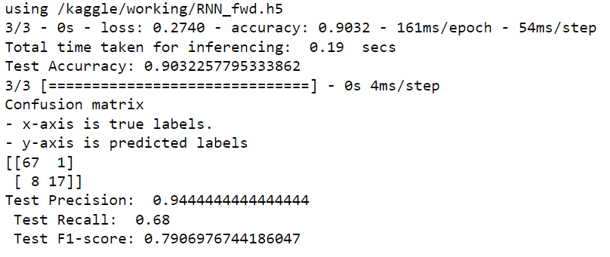

{REST OF THE CODE}
…
~Reference~

[1] Deep Learning for Predictive Maintenance https://github.com/Azure/lstms_for_predictive_maintenance/blob/master/Deep%20Learning%20Basics%20for%20Predictive%20Maintenance.ipynb/
[2] Predictive Maintenance: Step 2A of 3, train and evaluate regression models https://gallery.cortanaintelligence.com/Experiment/Predictive-Maintenance-Step-2A-of-3-train-and-evaluate-regression-models-2/
[3] A. Saxena and K. Goebel (2008). "Turbofan Engine Degradation Simulation Data Set", NASA Ames Prognostics Data Repository
https://ti.arc.nasa.gov/tech/dash/groups/pcoe/prognostic-data-repository/#turbofan
NASA Ames Research Center, Moffett Field, CA

